Types of Drive Systems and Their Selection

Vyas Bodke
Research Subsystem
Robo Manipal, MIT
Manipal, India
vyas.mitmpl2026@learner.manipal.edu

Abstract—This report discusses construction, working principles, advantages, limitations and applications of differential, omnidirectional, Mecanum, Ackermann, swerve, tracked, four wheel and skid steer drives.

Introduction
A drive system supplies the force to move a vehicle and works with its steering to control the path. The motor gives torque, the transmission carries it to the wheels or tracks, and contact with the ground produces motion. Wheel arrangement, steering method and ground contact affect what movements the vehicle can perform. The useful comparison is how well each arrangement performs the required job.

Differential Drive

Construction
It has two powered wheels, one on each side of the chassis, with their axes on the same line. Each wheel has an independently controlled motor, usually with a gearbox. One or more freely swivelling castor wheels support the rest of the chassis. The castors carry weight but do not normally supply driving force.
An encoder measures the rotation of each drive wheel. The controller compares the measured wheel speed with the required speed and adjusts the motor driver output. This helps the robot follow a straight line even when the motors or wheel loads are not exactly equal. No mechanical steering linkage is needed.
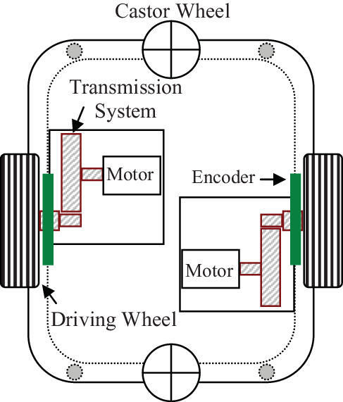

Working Principle
The robot turns by changing the difference between the two wheel speeds. Equal forward speeds produce straight travel. If the right wheel moves faster, the robot turns left because the right wheel follows a longer path. Stopping one wheel turns the robot about that wheel under ideal conditions. Driving the wheels at equal speeds in opposite directions turns it about the midpoint between them.
Let vl and vr be the left and right wheel ground speeds in m/s, and b be the distance between their contact centres in metres. With negligible slip, the midpoint speed v and counterclockwise angular speed ω are:
$v = (vr +vl)/2$ $ω = (vr - vl)/b$
The equations assume rolling contact without slip at the powered wheels.

Advantages and Limitations
Only two drive motors are required, and both speed and direction can be controlled through their rotation. Turning in place helps in narrow indoor areas. The term differential drive refers to the difference in wheel speeds, it does not need an automotive differential gearbox.
The robot cannot directly move sideways. It must turn, travel and turn again to reach a side way displaced position. Unequal wheel diameters, slip and castor resistance cause errors in odometry(finding of motion from wheel rotations).

Applications
Differential drive suits small delivery robots, floor cleaning robots and line followers when their routes mainly require forward travel and turns. It is a useful choice when low cost and simple control matter, and the robot has room to align itself. Unlike cars that use a mechanical differential to allow different wheel speeds while turning, differential drive robots control the speeds of their left and right wheels independently to steer.

Omnidirectional Drive

Construction
An omnidirectional robot can translate in any direction on a flat surface while controlling the direction its body faces. This section considers bases made with conventional omni wheels. An omni wheel has a powered main wheel and small passive rollers around its rim. These rollers allow the wheel to move sideways relative to its normal driven direction.
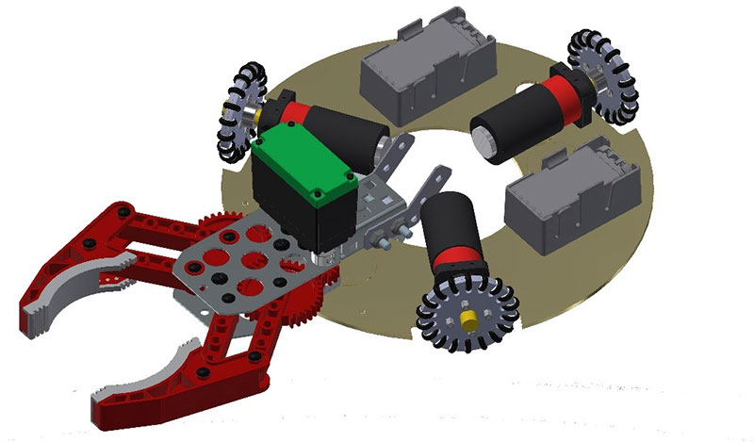
A common arrangement uses three omni wheels mounted 120 deg apart around the chassis, with their powered rolling directions tangent to a circle. Each wheel has its own motor. Four-wheel arrangements are also possible, provided the wheel directions allow the combined forces to control forward motion, sideways motion and rotation.

Working Principle
The main wheel rotation supplies motion in its powered direction. When the chassis also moves across the wheel, the small rollers turn freely to accommodate that motion. This removes the sideways rolling restriction imposed by an ordinary fixed wheel.
The controller converts the required chassis movement into a speed for each wheel. For translation, the wheel contributions combine in the desired direction without producing a rotation. In a symmetric three wheel arrangement, equal tangential wheel speeds in the same rotational sense turn the chassis about its centre. Translation and rotation can also be commanded together.
An omni wheel on its own does not make a robot omnidirectional. The number, orientation and control of the wheels must allow independent control of the required motions.

Advantages and Limitations
An omni wheel base can make small lateral corrections while a robot’s camera or gripper keeps facing its target. It achieves this without steering motors. A three wheel layout also has three ground contact points, which avoids the rocking that a rigid four contact chassis can experience on a slightly uneven surface.
The rollers and their bearings add parts that can wear or collect debris. Gaps between roller contacts can cause vibration, especially with small wheels. Step edges and loose ground can disturb their motion. Load capacity depends on the wheel, roller and bearing ratings. A three wheel robot also needs its centre of mass positioned safely within the triangular support area, with allowance for acceleration and slopes.

Applications
Omnidirectional drives are used in mobile manipulators in factories, where a robot carrying a robotic arm may need to position components during assembly. The robot can move sideways to align its arm with the workpiece without rotating its entire body. This makes omni drive more suitable than differential drive for tasks requiring frequent lateral adjustments in confined spaces. They are better on smooth floors, where precise movement is more valuable than crossing large obstacles.

Mecanum Drive

Construction
A typical Mecanum drive has four independently powered wheels at the corners of a rectangular chassis. The wheel axes remain fixed. Each wheel carries freely rotating rollers inclined at approximately 45° to the main wheel axis. The usual arrangement uses opposite roller handedness on adjacent wheels, forming an X-shaped roller pattern when viewed from above.
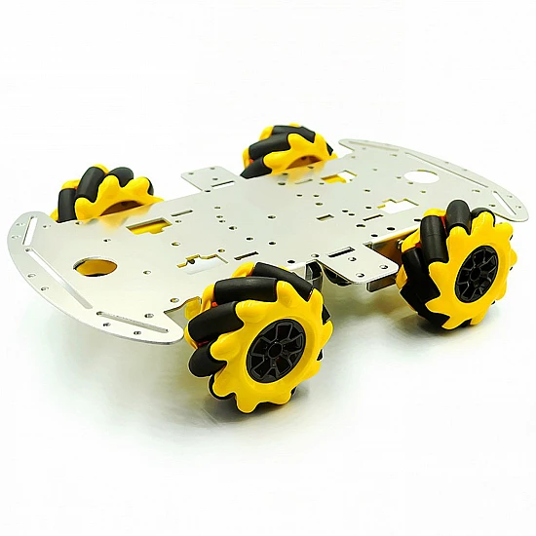
Four motors, motor drivers and suitable speed feedback control the main wheel rotations. Separate steering is unnecessary. All four wheels must maintain adequate ground contact, so chassis flexibility or suspension may be needed when the floor is not perfectly level.

Working Principle
The angled rollers make the wheel ground force act with both longitudinal and lateral components. By combining the forces from the four wheels, the controller can cancel unwanted components and add the components needed for required movement. The small rollers rotate passively as the chassis moves across their free rolling direction.
For the usual X arrangement, define forward wheel rotation as the rotation that would drive a normal wheel toward the front of the robot. Driving all four wheels forward gives forward travel because the lateral contributions cancel. To move left, the front-left and rear-right wheels run backward while the front-right and rear-left wheels run forward. The longitudinal contributions cancel and the lateral contributions add toward the left.
To rotate left about the chassis centre, the left wheels run backward and the right wheels run forward. The controller can combine forward, sideways and rotational commands. 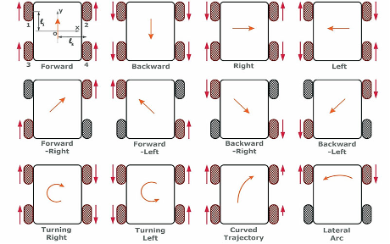

Advantages and Limitations
Mecanum drive allows a rectangular platform to move sideways, diagonally or around its centre without turning the wheel assemblies. It is useful where a vehicle must position a load in a restricted space. The fixed wheel mountings also leave more freedom for arranging the chassis and payload than some steering designs.
Roller contact, bearing friction and wheel loading affect the available force and efficiency. Small rollers can struggle with debris, gaps and uneven ground. A slipping wheel can cause an unintended sideways movement or rotation. Position feedback may therefore be needed for accurate docking. Heavy loads are possible with appropriately rated industrial Mecanum systems, so load capacity should be checked from the actual wheel design.

Applications
Mecanum drives suit rectangular mobile platforms that must move sideways to position a load in a restricted space. A factory transport platform can approach a machine sideways and align its load without making a large turn.

Ackermann Steering Drive

Construction
A common Ackermann arrangement has two steerable front wheels and two rear wheels. Steering arms and a connecting linkage turn the front wheels through different angles. A rack and pinion system or a servo can actuate the linkage. The wheels may be driven at the front, rear or both axles, because the steering geometry does not determine which wheels receive power.
The inner wheel follows a smaller circle during a turn, so it must steer through a larger angle than the outer wheel. The linkage is designed to approximate this relationship over its operating range. Driven wheels also need to rotate at different speeds during a turn, which can be accommodated by a differential or separate motor control.

Working Principle
When the vehicle turns, the inner front wheel follows a smaller circle than the outer wheel. The steering linkage turns the inner wheel through a larger angle so that both wheels follow their paths with less sideways slipping. The steering arms and connecting links produce this difference in angle as they move.
Ideally, all four wheels follow circular paths around the same turning centre. The outer wheels cover a longer distance in the same time, so they must rotate faster than the inner wheels. A differential or separate motor control allows this speed difference at the driven wheels.
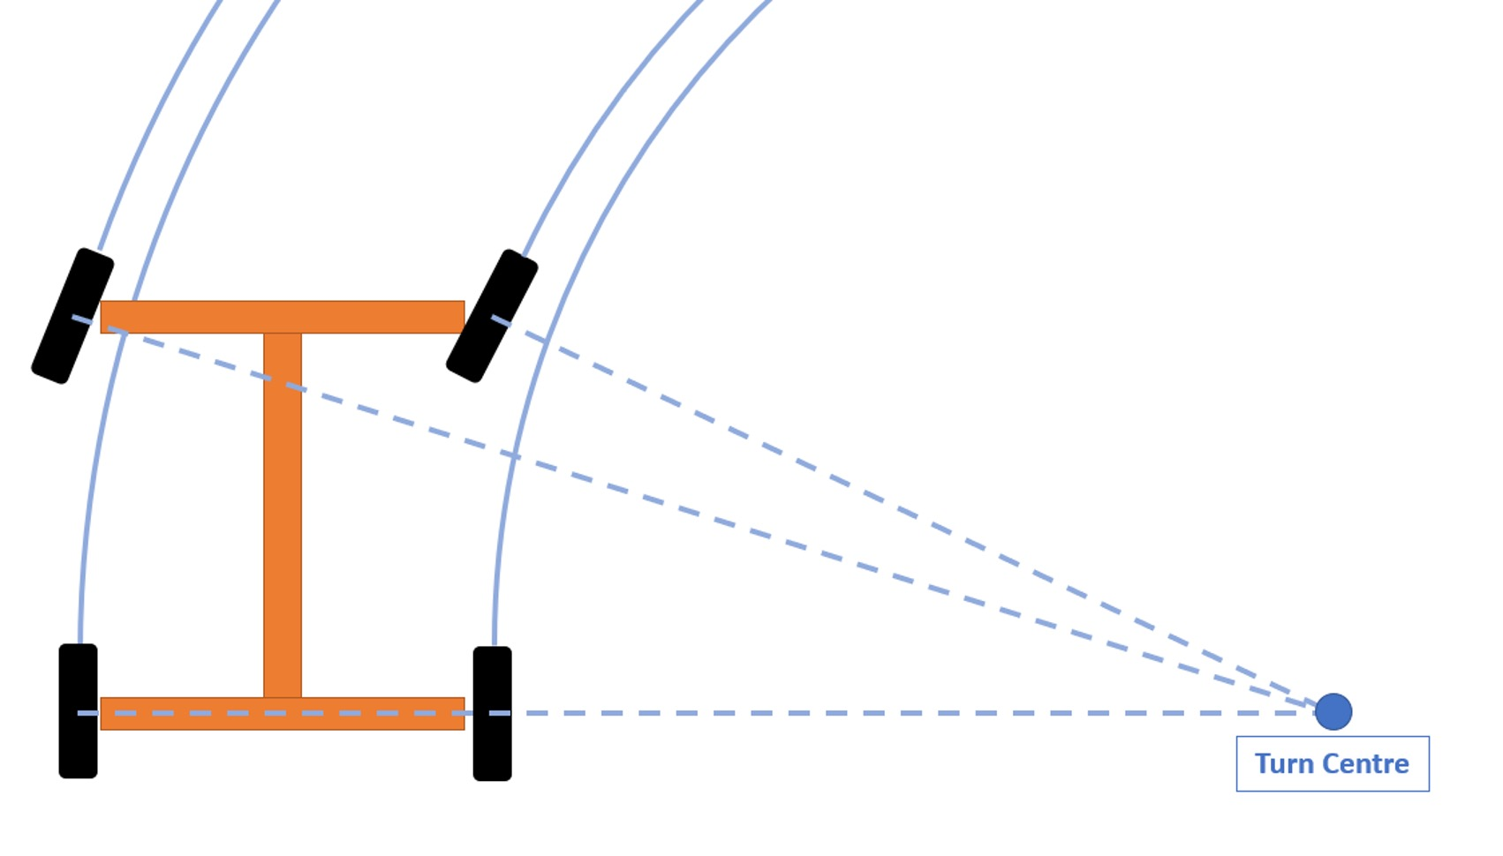

Advantages and Limitations
The tyres are steered along their paths instead of being deliberately dragged sideways. This makes Ackermann steering suitable for repeated travel along roads and long curved routes. Conventional tyres can provide useful traction and load capacity.
A normal front-steered arrangement cannot turn about its centre or move sideways. Its minimum turning radius depends on wheelbase and steering limits, so narrow spaces may require reversing. Steering joints and alignment also need attention. The geometry alone does not ensure high speed stability, tyres, suspension, centre of mass and speed must be considered together.

Applications
Cars and car-like robots use Ackermann steering because most of their movement is forward travel along smooth curves. An outdoor delivery rover may use it to reduce tyre scrub over a long route. It becomes less convenient when the robot must repeatedly reverse its heading in a space only slightly larger than its footprint.

Swerve Drive

Construction
A common swerve drive has four modules, each containing a conventional traction wheel, a drive motor and a steering motor. The drive motor spins the wheel through a transmission. The steering motor rotates the wheel assembly about a near-vertical axis. Bearings support the module and transfer the vehicle load to the wheel.
A drive encoder measures wheel rotation, and a steering encoder measures the angle of the module. Four such modules normally use eight motors, although other mechanical arrangements exist. The design also needs secure wiring, accurate alignment and access to replace worn wheels or service the transmission.

Working Principle
For translation, the modules point in the desired travel direction and drive at the required speed. Pointing all modules sideways lets the chassis move sideways while keeping the same heading. To rotate about a selected centre, each wheel is aligned tangent to its circular path, and its speed depends on its distance from that centre.
For combined movement, the controller adds the translational velocity and the rotational contribution at each wheel location. It then calculates the required speed and angle for that module. The steering feedback loop compares the commanded and measured angles, and changes motor output to reduce the difference.
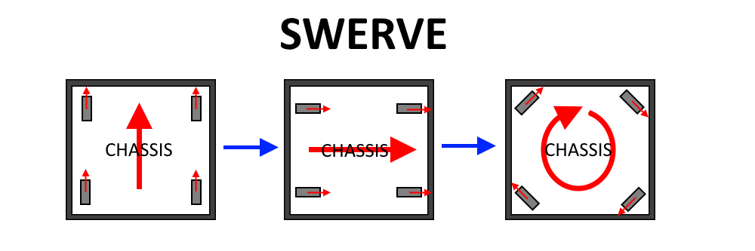
A wheel can produce the same movement by turning its module 180° and reversing its drive direction. Controllers use this equivalent arrangement to avoid unnecessary steering travel. The modules still take time to reach a new angle, so their drive speeds may be reduced during alignment to prevent the tyres from scrubbing against the intended motion.

Advantages and Limitations
Swerve combines movement in different directions with the traction characteristics of conventional tyres. It can keep a robot facing a target while the chassis follows a different path. Its ability to steer the wheels also avoids relying on the passive rollers used by some Mecanum and omni wheels.
The extra motors, sensors, gears and bearings increase cost, weight and maintenance. Incorrect steering offsets can make the wheels oppose each other, causing unwanted motion, higher current and tyre wear. Accurate calibration and coordinated control are necessary. Swerve also needs suitable wheel diameter, clearance and suspension if it is expected to travel over rough ground.

Applications
A competition robot can justify swerve when it must change direction quickly, move around other robots and keep an intake or launcher facing a target. It is also useful for mobile equipment that needs flexible positioning with ordinary traction wheels. For a robot that only follows a simple route, these benefits may not justify the additional mechanisms and control work.

Tracked Drive

Construction
A tracked drive has a continuous track on each side of the chassis. The track passes around a drive wheel and a guide or idler wheel. The drive wheel receives power from the motor and moves the track, while the idler guides it around the other end. Smaller mid rollers or bogie wheels support the vehicle’s weight and keep the lower part of the track in contact with the ground.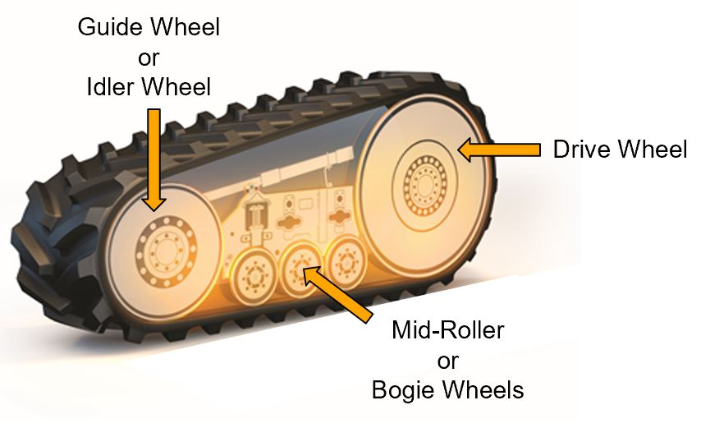
The common arrangement considered here controls the left and right tracks independently. Track width, length in contact with the ground influence load distribution and obstacle handling.

Working Principle
The sprocket circulates the track while the portion touching the ground transmits the driving force. Equal track speeds produce approximately straight travel. A difference in speeds turns the vehicle. With sufficient torque and suitable ground conditions, opposite track directions can turn it about its centre.
Turning requires lateral slip or deformation across the contact patches. Their actual turning radius cannot always be predicted accurately from the commanded track speeds because the tracks and ground do not behave like two ideal wheels rolling without slip.

Advantages and Limitations
Tracks can spread the supported weight over a large area, reducing mean ground pressure. Actual pressure is uneven and changes with terrain and payload position.
A large contact area can reduce sinking in soft soil, while track length can help bridge small gaps. However, climbing ability still depends on grip, track engagement, torque and stability. Tracks do not automatically make a vehicle safe on steep slopes or able to climb stairs.
The undercarriage adds weight and moving parts. Track flexing, joint friction and skid turning consume energy. Turning on hard surfaces can increase wear and disturb the surface. Incorrect tension, debris and side loads may damage the track or pull it off its guides, so inspection and cleaning are part of normal operation.

Applications
Tracked vehicles suit work where sinking or loss of contact is a major concern, such as travel over some loose surfaces. A robot working on soft ground may accept their maintenance and energy costs to gain better support. A robot travelling mainly on smooth indoor floors will gain little from that extra contact area.

Four Wheel Drive

Construction
Four-wheel drive supplies driving torque to all four wheels. A mechanical system can use a central power source, transfer case, drive shafts and axle differentials. An electric robot may use four wheel motors or a transmission that drives both wheels on each side. Steering is chosen separately.
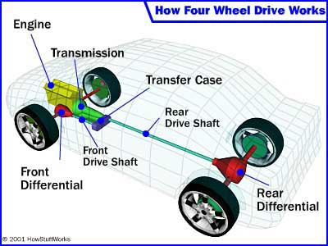
Suspension or chassis compliance helps keep the wheels in contact with uneven ground. The load carried by each wheel matters because an unloaded wheel contributes little traction, even when its motor is running. Tyre diameter, tread and ground clearance remain important parts of the design.

Working Principle
Driving all four wheels allows the ground contact at both axles to contribute to propulsion. This can help when a two wheel drive vehicle cannot transmit enough force through its driven tyres. The available benefit depends on wheel loading, surface grip and torque distribution, four driven wheels do not create extra power from the same motor.
During a turn, the wheels follow different path lengths. In a wheel steered vehicle, axle differentials or independent motor control let them rotate at the required speeds. In a four-wheel skid-steer robot, the speed difference between the two sides turns the chassis, with tyre slip accommodating the motion.
A conventional open differential can limit the torque transmitted through an axle when one wheel has very little grip. Differential locks or traction control can improve usable propulsion in such conditions. Locks also restrict speed differences, so mechanically locked part time 4WD can build stress in the drivetrain during tight turns on dry, high-grip ground.

Advantages and Limitations
4WD can improve starting, climbing and pulling when the vehicle is limited by traction at only two driven wheels. It also provides several load-bearing drive contacts. The additional motors or transmission parts increase mass, cost and maintenance, and can increase losses.
4WD alone does not determine motion. An Ackermann steered 4WD rover follows a finite turning circle, while a skid steer 4WD rover may turn in place at the cost of tyre friction.

Applications
An outdoor inspection rover can use this when slopes or changing ground contact make two driven wheels inadequate. Ackermann steering may suit a long route with room for turns. Skid steering may suit a compact rover that needs to turn in restricted areas. The designer must select both the powered wheel arrangement and the steering method to meet the task.

Skid Steer Drive

Construction
A wheeled skid-steer base commonly has four or six conventional wheels fixed in the forward direction. Wheels on each side are driven together using chains, belts or gears, or their motors are controlled to act as one side. The chassis does not need a linkage that changes the wheel steering angles.
The important difference from the basic two wheel differential drive is the presence of fixed contacts at several positions along the chassis. During a turn, the front and rear wheels cannot all follow their circular paths by pure rolling in their fixed directions. Some sideways motion at the contacts is necessary. Tracks can use the same steering principle.

Working Principle
Different left and right speeds create a turning action. The wheels roll forward or backward while also scrubbing sideways across the ground. Equal side speeds give approximately straight travel. Equal and opposite side speeds can turn the chassis in place.
The actual turn depends on tyre grip, wheel loading, contact spacing and the ground surface.

Advantages and Limitations
Skid steering provides tight turns with a compact mechanical arrangement. It can carry several drive wheels without adding steering joints at each wheel. This can be useful for rugged machines where exposed steering linkages would be difficult to package or protect.
Sideways tyre scrub increases wear, drive stress and the force needed to turn. High grip floors can produce a much larger turning load than straight travel. On loose ground, skidding may be easier.
The motor and transmission must therefore be checked for difficult turns with the full load. Choosing them only from the power needed for straight travel can leave the robot unable to turn or cause overheating during repeated manoeuvres.

Applications
Skid steer loaders use this method to move within compact work areas. Small inspection and competition robots can use it when tight turning and a simple wheel arrangement matter more than low tyre wear. Frequent turning on delicate floors or long routes on firm surfaces may favour a system that steers its wheels along the path.

References

IEEE conference templates contain guidance text for composing and formatting conference papers. Please ensure that all template text is removed from your conference paper prior to submission to the conference. Failure to remove template text from your paper may result in your paper not being published.

